Offensive Tool Testing — Lesson Plan
Classification: UNCLASSIFIED

1. Administrative and metadata

1.1 Lesson title
Offensive Tool Testing

1.2 Module length
60 minutes (1 hours)
Schedule slot is 60 minutes. Content-guide is instructor-flexible.

1.3 Terminal and enabling learning objectives
- TLO-4: At the end of the Counterstrike Operator Course, students will be able to rapidly access and effect adversary infrastructure
- ELO-80: Test an unfamiliar offensive tool and produce technically acceptable documentation.

1.4 Prerequisites
- B04.M25: Threat-Rep Mission Rehearsal Lab

2. Personnel, range, and environment

2.1 Instructor and cadre
- 1 × instructor (required)
- 0 × range_engineer (not_applicable: Lecture Module; no range engineer required)
- 0 × auditor (not_applicable: Not used by this course)
- 0 × oversight_officer (not_applicable: Not used by this course)

2.2 Materials and resources
Instructor resources and pre-class preparation
- Classroom projector and screen; whiteboard for the opening contract
- Parent or sibling briefs listed in this Module folder
- Live tabs and references already named in this file's header
- Do not project flags, tokens, or answer-key values
Student resources and environment
- Student brief, student guide, or homework file in this Module folder when present
- Assigned range, workstation, or lab stack named in the student-facing file
- No extra kit beyond what the student-facing file already lists

3. Assessment and evaluation
ELO | Method | Related Module | Criteria
ELO-80 | in-class Q&A | — | In-class questions and check on learning in the content guide.

4. Instructional delivery

4.1 Opening, attention grabber, and motivator

Option 1 (Interactive / Whiteboard / Kinesthetic)
- Say: "Today has three deliverables: judge whether a new tool is actually good for the mission, employ it on the exploitation range you already built — Kali ops, the redirector you chose, and the Windows target — and write it up well enough that someone else can run it without you. A peer later proves that last part using only what you wrote. Do not stand up a second harness."
- Do: Put the lesson contract on the board. Keep products from the prerequisite Module available.
- Ask (Q): Which of these three — evaluate, employ on the range you built, document — do you think your team is weakest at?
- Expected Response (A): Facilitation. Use the Say/Do already on this row; do not force a single keyed answer.

Option 2 (Digital Slide / Virtual / Slide Deck)
- Say: "Today has three deliverables: judge whether a new tool is actually good for the mission, employ it on the exploitation range you already built — Kali ops, the redirector you chose, and the Windows target — and write it up well enough that someone else can run it without you. A peer later proves that last part using only what you wrote. Do not stand up a second harness."
- Show: The title slide and lesson objectives.
- Do: Confirm stations can open the required tool or file before the first teaching row.
- Ask (Q): Which of these three — evaluate, employ on the range you built, document — do you think your team is weakest at?
- Expected Response (A): Facilitation. Use the Say/Do already on this row; do not force a single keyed answer.

4.2 Side-by-side table of instruction
Visual / Slide Asset | Instructional Delivery & Instructor Notes
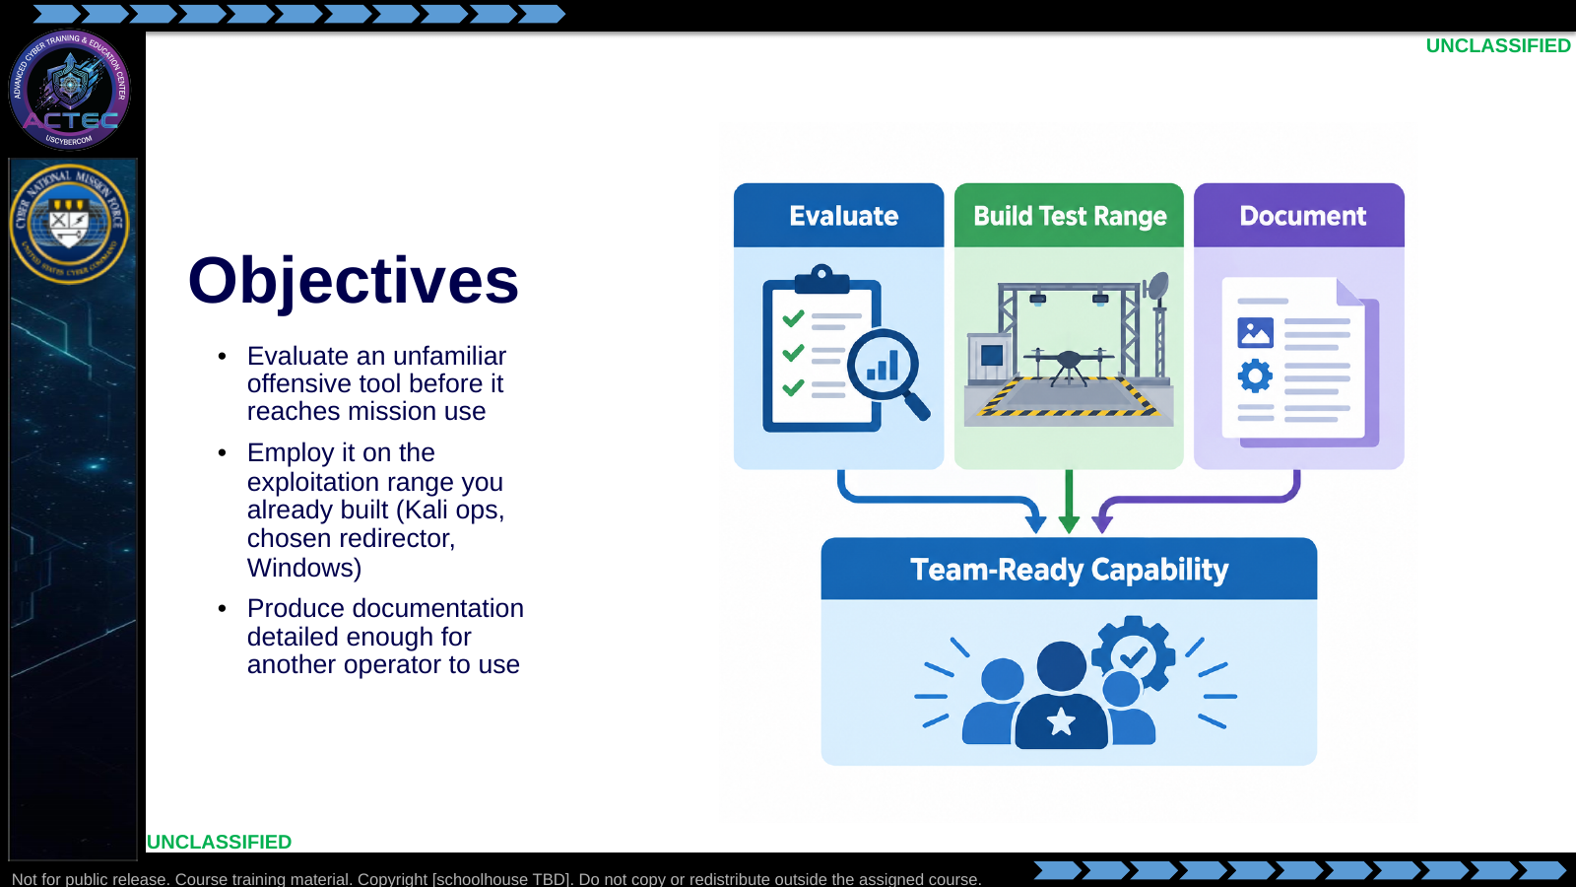  Slide 1: Objectives  Duration: 7 min | Say: "Today has three deliverables: judge whether a new tool is actually good for the mission, employ it on the exploitation range you already built — Kali ops, the redirector you chose, and the Windows target — and write it up well enough that someone else can run it without you. A peer later proves that last part using only what you wrote. Do not stand up a second harness."  Show: Point out that the test bed is the range already built, not a new cell.  Do: Ask: "Which of these three — evaluate, employ on the range you built, document — do you think your team is weakest at?"  Ask (Q): Which of these three — evaluate, employ on the range you built, document — do you think your team is weakest at?  Expected Response (A): Facilitation. Use the Say/Do already on this row; do not force a single keyed answer.
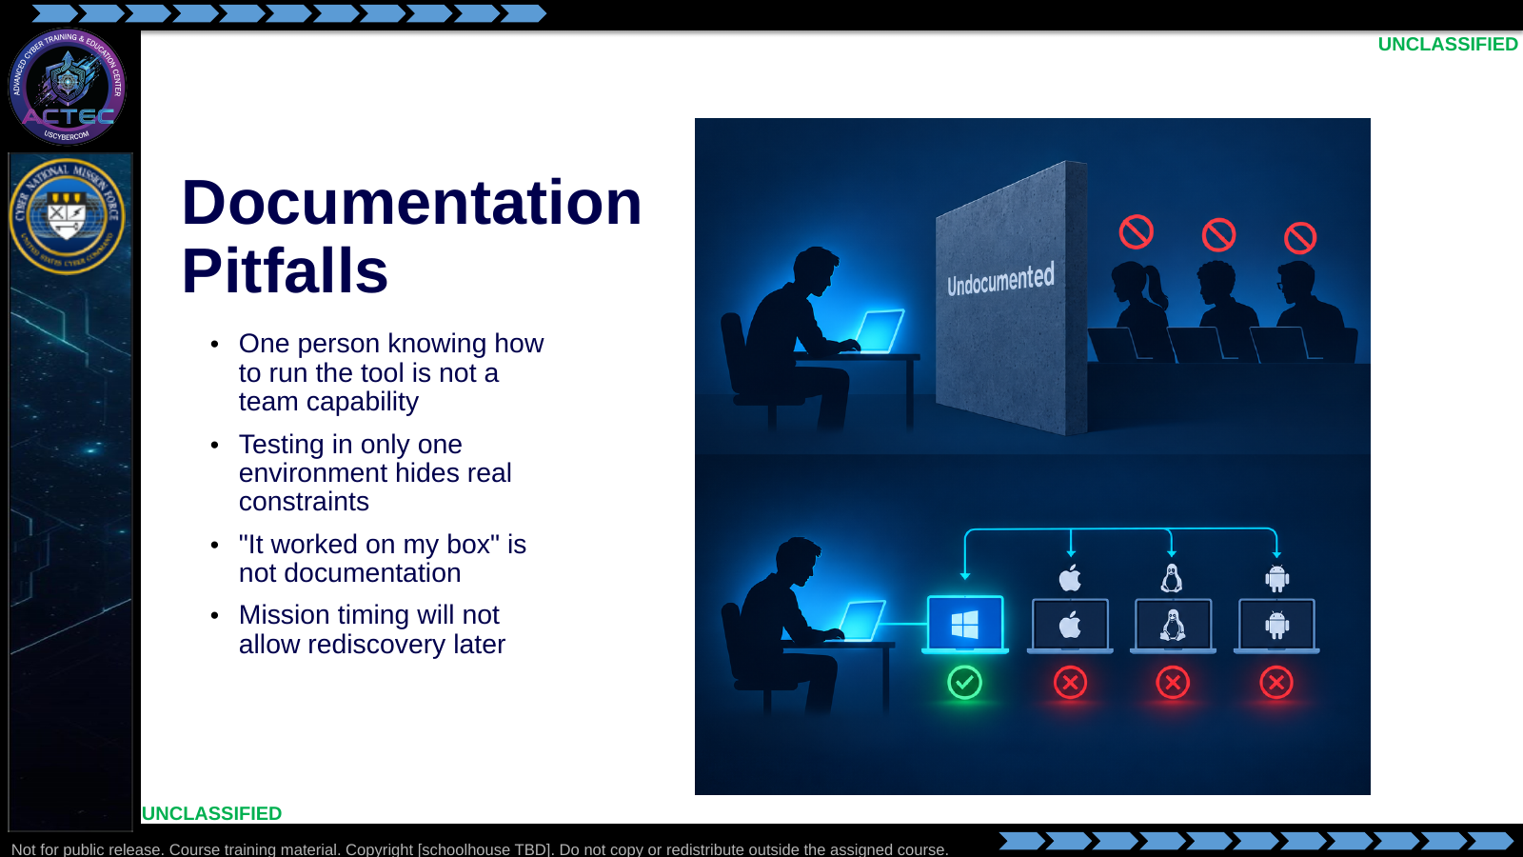  Slide 2: Documentation Pitfalls  Duration: 7 min | Say: "Two failure modes here. First: if only you can run it, the team doesn't have it — swap, casualty, or shift change exposes every undocumented step. Second: testing once on your machine and writing it up as gospel is a trap. Run it against more than one config before you claim it works, and write down where it didn't. 'Worked on my box' is not evidence, it's a guess with confidence."  Show: Point at the wall graphic, then the multi-OS panel.  Do: Collect one quick story: "When has a tool broken because it only ran on one specific setup?"  Ask (Q): What is the operational takeaway from this row?  Expected Response (A): Facilitation. Restate the Say/Do in operator terms. Do not invent a new teaching point.
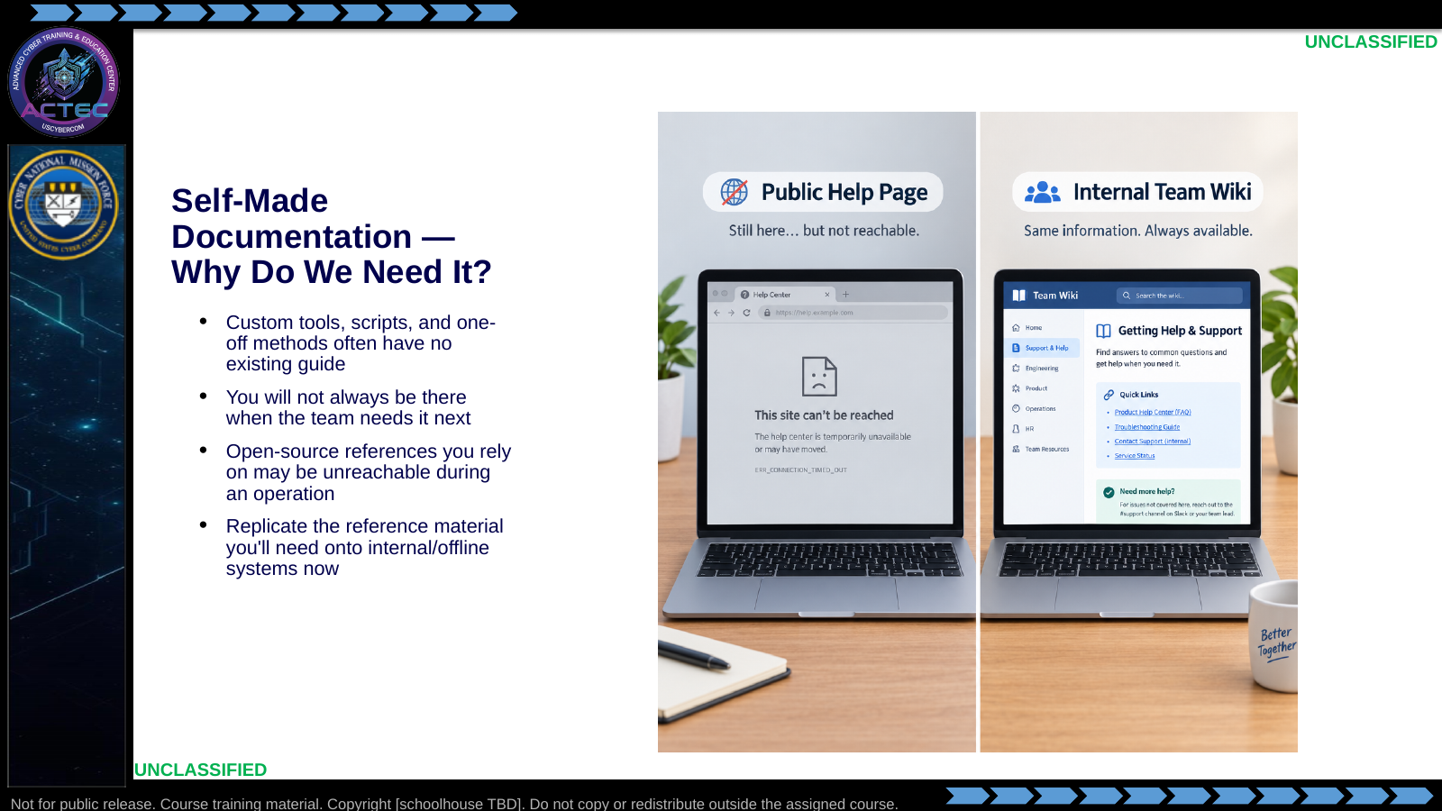  Slide 3: Self-Made Documentation — Why Do We Need It?  Duration: 7 min | Say: "This isn't just about commercial C2 frameworks. Anything your team builds — a custom script, a one-off technique, a wrapper around someone else's tool — has zero public documentation by definition. And even for public tools, don't assume you'll have internet access to that vendor wiki mid-operation. If you know you'll need a reference, capture it on an internal system now, while you have access, in your own words."  Show: Emphasize the greyed-out browser tab — that's the moment this slide is solving for.  Do: Ask: "Name one tool or script your team uses today that only exists as 'ask so-and-so.'"  Ask (Q): Name one tool or script your team uses today that only exists as 'ask so-and-so.'  Expected Response (A): Facilitation. Use the Say/Do already on this row; do not force a single keyed answer.
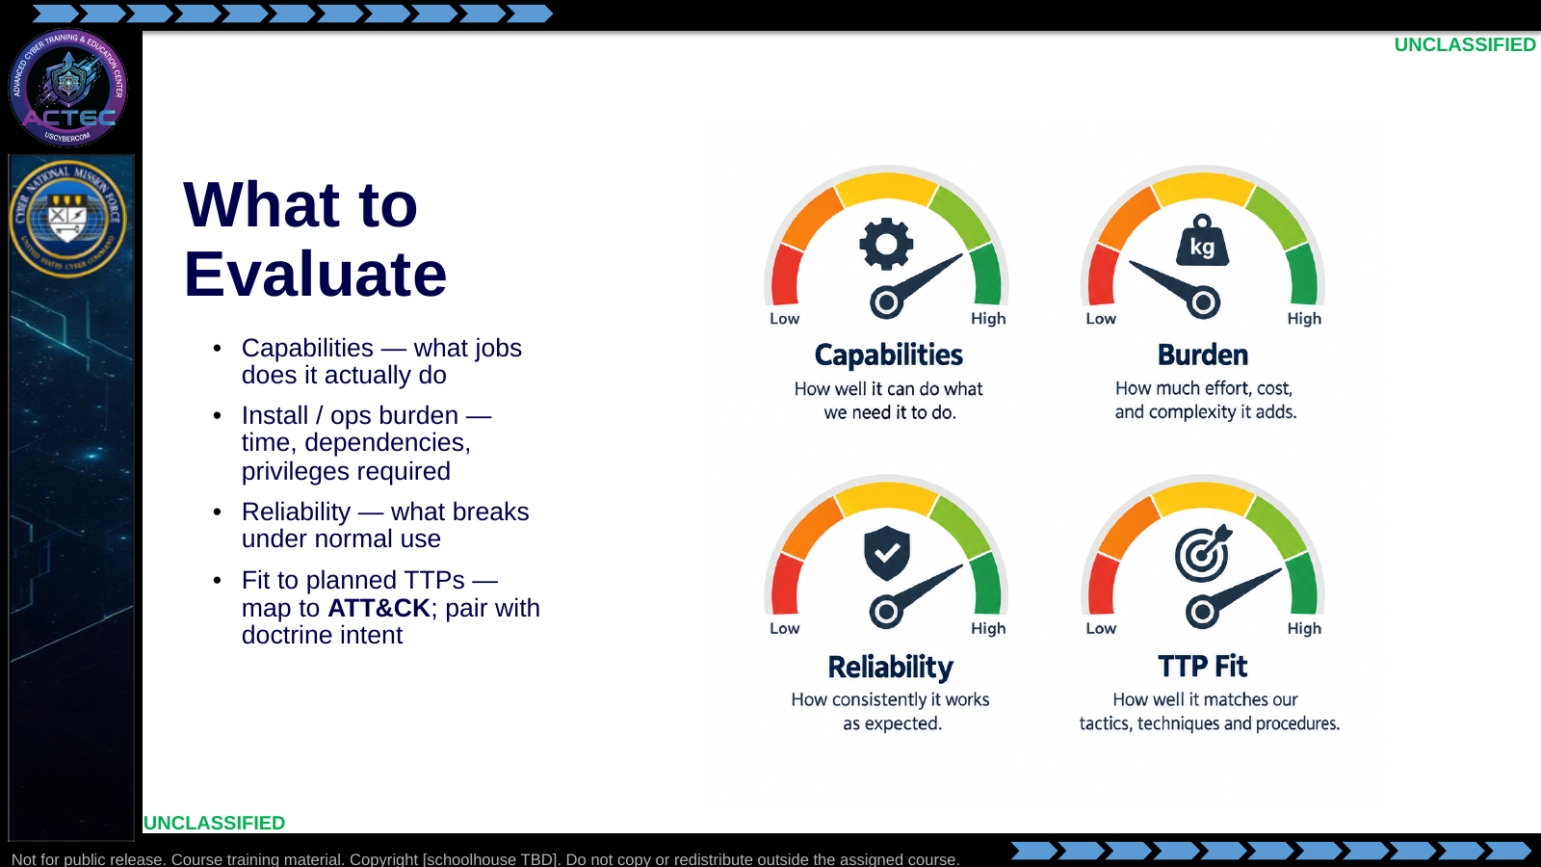  Slide 4: What to Evaluate  Duration: 7 min | Say: "Score the tool against the mission, not the marketing page. A tool with great capabilities but a two-hour install and root-only operation may not be worth it. When you name the TTP it supports, pair the doctrinal intent — for example reconnoiter or later degrade — with the ATT&CK technique you expect to exercise. We'll cover OPSEC footprint separately when we get to documentation — that's evidence you gather during testing, not a judgment call you make up front."  Show: Walk one example tool through all four gauges in one sentence each.  Do: Ask which of these four gets skipped most often under time pressure — expect "reliability" or "TTP fit."  Ask (Q): What is the operational takeaway from this row?  Expected Response (A): Facilitation. Restate the Say/Do in operator terms. Do not invent a new teaching point.
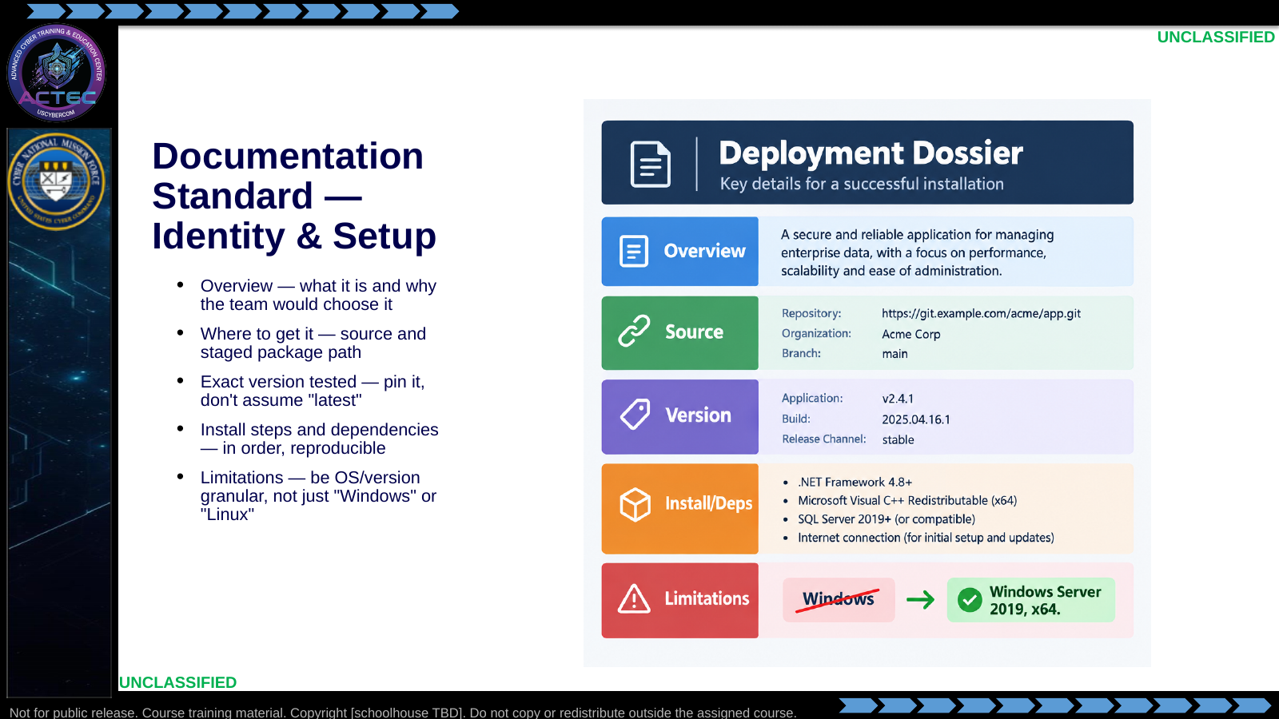  Slide 5: Documentation Standard — Identity & Setup  Duration: 7 min | Say: "This half of the dossier answers 'what is this and can I get the same thing running.' Overview earns the reader's buy-in. Where you got it and the exact version matter because a tool that works on one release can break on the next. Install steps must be reproducible in order. And limitations need to be specific — 'runs on Windows' tells the next operator nothing useful; state the OS family, version, and architecture you actually tested."  Show: Point at the crossed-out "Windows" callout as the example of the mistake to avoid.  Do: Ask: "If your dossier just says 'Linux,' what question is your peer stuck asking you?"  Ask (Q): If your dossier just says 'Linux,' what question is your peer stuck asking you?  Expected Response (A): Facilitation. Use the Say/Do already on this row; do not force a single keyed answer.
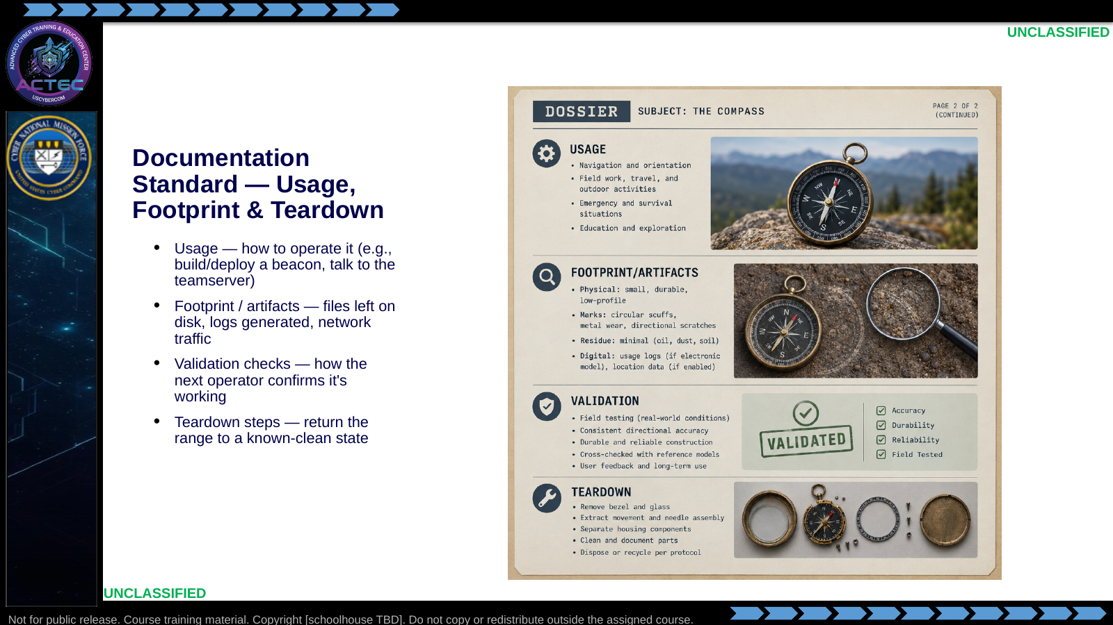  Slide 6: Documentation Standard — Usage, Footprint & Teardown  Duration: 7 min | Say: "This half answers 'can I run it and do I know what it leaves behind.' Usage is the happy-path operator workflow — concrete verbs, not vibes. Footprint and artifacts are the OPSEC read: what would a defender see — files on disk, logs from install or use, network traffic signatures. Validation proves it worked. Teardown returns the environment to a known state — leftover listeners are exactly the mess this whole process exists to prevent."  Show: Tell them the lab rubric grades both halves of this standard, especially whether a peer succeeds from the dossier alone.  Do: Ask which section students are most tempted to shortchange — usually footprint or limitations. Demand honesty.  Ask (Q): What is the operational takeaway from this row?  Expected Response (A): Facilitation. Restate the Say/Do in operator terms. Do not invent a new teaching point.
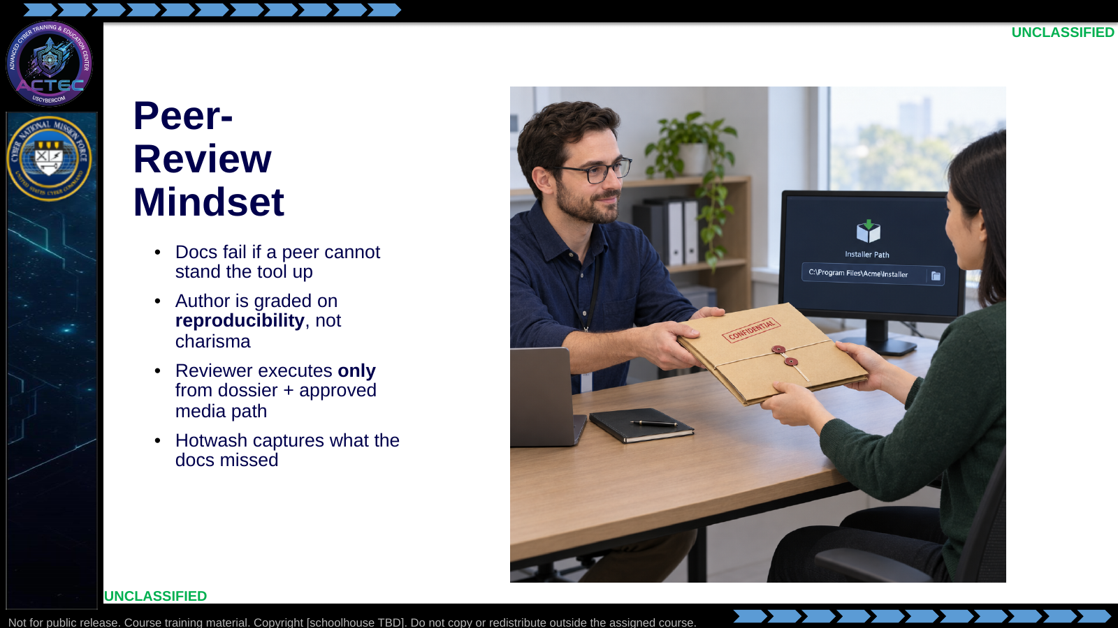  Slide 7: Peer-Review Mindset  Duration: 7 min | Say: "In the lab you will swap. The reviewer does not get a walkthrough from you. If they cannot install and complete a minimal validation task from your writing, your documentation failed — even if you personally know the tool cold."  Show: Emphasize sealed-dossier constraint.  Do: Set expectation: no coaching during the peer execute window.  Ask (Q): What is the operational takeaway from this row?  Expected Response (A): Facilitation. Restate the Say/Do in operator terms. Do not invent a new teaching point.
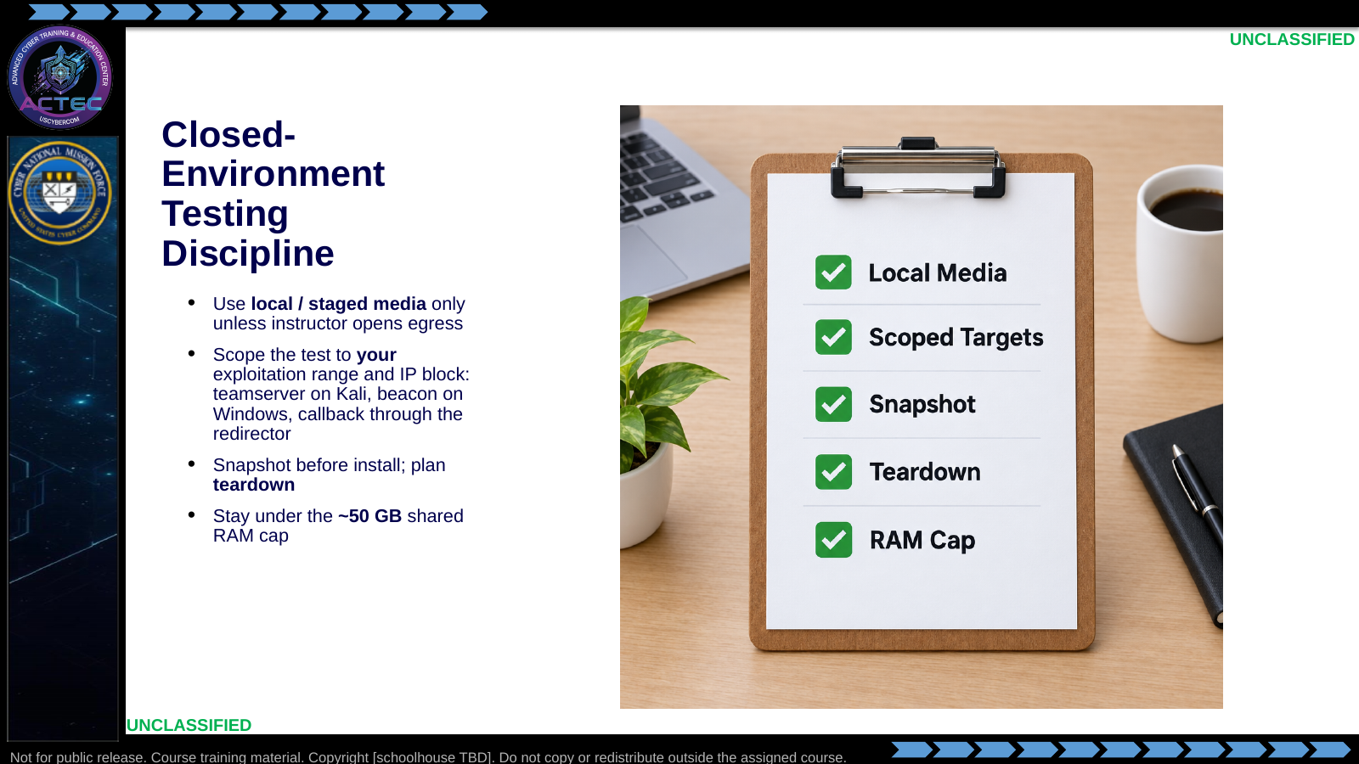  Slide 8: Closed-Environment Testing Discipline  Duration: 7 min | Say: "You are still on the shared cluster, on the cell you already built. Put the teamserver on the Kali ops host. Put the beacon on the Windows target and make the callback traverse the redirector. Power down unused VMs if you need headroom. Do not scan classmates. Do not stand up a second server-and-target pair. Do not assume internet for installers. Teardown is part of the test — leftover listeners are a self-inflicted failure you'll answer for in the hotwash."  Show: Tie RAM discipline back to OE rehearsal.  Do: Confirm students know which VMs they will power off before tool install.  Ask (Q): What is the operational takeaway from this row?  Expected Response (A): Facilitation. Restate the Say/Do in operator terms. Do not invent a new teaching point.
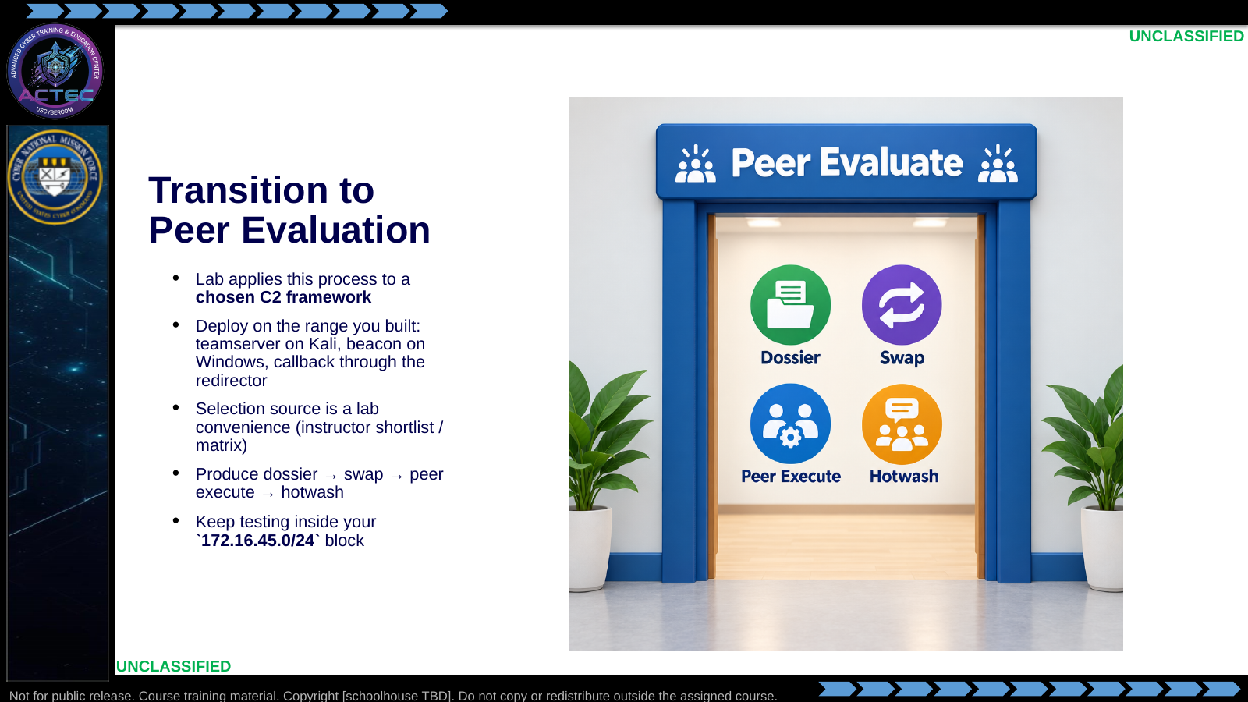  Slide 9: Transition to Peer Evaluation  Duration: 7 min | Say: "We are not teaching a particular C2 product in this lecture. In the lab you will pick one approved framework, install it on the exploitation range you already built, document that employment, then prove the docs with a peer who uses their own cell. Stay in your address block and RAM budget."  Show: Hand out the peer-evaluation brief and shortlist / selection rules.  Do: Break, then start peer evaluation.  Ask (Q): What is the operational takeaway from this row?  Expected Response (A): Facilitation. Restate the Say/Do in operator terms. Do not invent a new teaching point.

4.3 Lesson summary
- B04.M04-offensive-tool-testing is executed as a generated lesson plan from this file.
- Assessment methods live on module.yaml; do not invent extra official ELOs.
- Later practice in this Block continues from the product this session collects.

4.4 Questions and check on learning
- Ask (Q): Which of these three — evaluate, employ on the range you built, document — do you think your team is weakest at?
- Expected Response (A): Facilitation. Use the Say/Do already on this row; do not force a single keyed answer.
- Ask (Q): What is the operational takeaway from this row?
- Expected Response (A): Facilitation. Restate the Say/Do in operator terms. Do not invent a new teaching point.
- Ask (Q): Name one tool or script your team uses today that only exists as 'ask so-and-so.'
- Expected Response (A): Facilitation. Use the Say/Do already on this row; do not force a single keyed answer.

5. Classification
Classification: UNCLASSIFIED

